ReCoverCA Homebuyer Assistance Program
Homebuyer Event – Social Media Post (template language)
Feb 26 – Event in Clearlake (Lake County)

(Graphic)
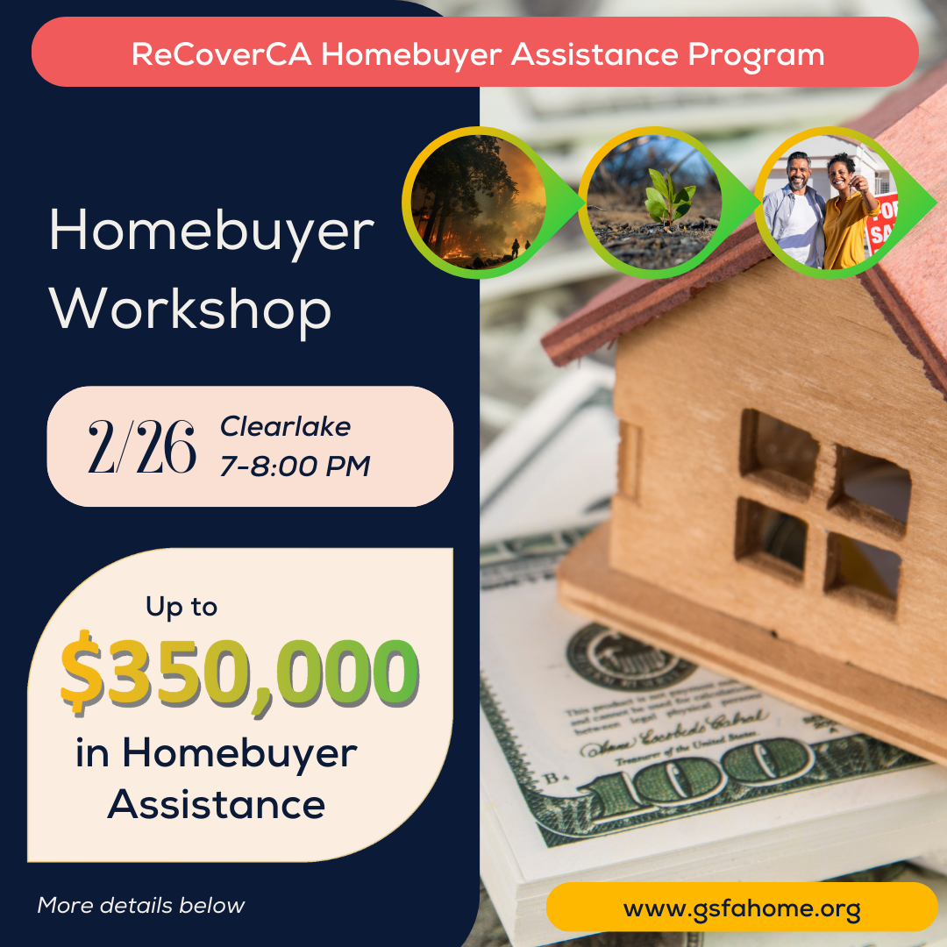

(Post body)
🏠 Lake County Residents -- If you were living in Zip Code 95422 in 2017, within a High or Very High Fire Severity Zone, you could receive up to $350,000 to help you buy a home in California outside these high-risk areas.
Join us on February 26, 2025 for a FREE workshop for the ReCoverCA Homebuyer Assistance Program.
Event Details: 🗓 Date: February 26, 2025
🕖 Time: 7:00-8:00 PM
📍 Location: Best Western El Grande Inn, 15135 Lakeshore Dr., Clearlake, CA 95422
This workshop is open to households impacted by the 2017 wildfires in Lake County, as well as professionals supporting recovery efforts or providing community outreach.
🔑 What you’ll learn:
- How to apply for homebuyer assistance up to $350,000.
- Eligibility requirements, income limits, and the application process.
- Step-by-step guidance from experts in the field.
Space is limited – RSVP today!
https://qrco.de/bfimJm

#ReCoverCA #LakeCounty #HomebuyerAssistance #DownPaymentAssistance #WildfireRecovery #CommunityRecovery #Clearlake #sulfurfire #gsfa

